MICHAEL M. DUBIN
Certified Public Accountant
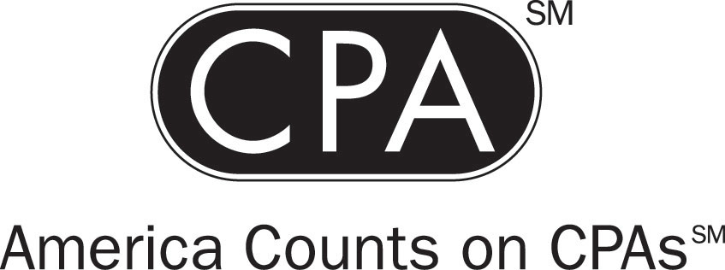
90 Hampshire Road
Rockville Centre, NY 11570-2231
Office (516) 536-3271
Fax (516) 543-5347
Email mdubincpa@aol.com

June 10, 2011

Dear Prospective Client,

IS YOUR PRESENT ACCOUNTANT PROVIDING YOU WITH THE PERSONAL SERVICE THAT YOU EXPECT?

DO YOU TRUST THAT YOUR TAX RETURNS ARE BEING PREPARED FOR THE MAXIMUM RESULT THAT YOU ARE ENTILTLED TO?

IF THERE IS ANY DOUBT, PLEASE CALL ME AT THE NUMBER ABOVE FOR A FREE EVALUATION OF YOUR TAX RETURNS.

I am presently in the midst of expanding my practice base. This expansion is due to my recent retirement from the position of Chief Financial Officer with the United Federation of Teachers, a Major New York City Labor Union., after 31 years of dedicated service.

I have been providing tax and accounting services for over thirty years. I am presently a member in good standing of both the NY State Society of CPAs and the American Institute of CPAs. Membership requires the completion of a minimum of forty hours of continuing professional education annually. In addition, for the convenience of my clients, I hold a NY State Notary Public License.

As a full service accountant, I offer a complete array of services as seen in the following attachment.

All services are performed exclusively by myself, and are never assigned to any non - professional third parties, which to my chagrin, are the case in many practices. In addition, my office is fully automated for your convenience.
If you or any of your relatives, friends, neighbors, business associates, etc., requires any of these services I would sincerely appreciate your recommendation to anyone of them.
Please call me if you have any questions. Thanking you in advance for your consideration.

Sincerely,

Michael M. Dubin

